Here are steps to guide to use the Travel Guide application

Here is a video to show you how to run the application. <https://youtu.be/2Ig8K0JOcRY>

1. First of all, you need to install the packages in “requirements.txt”.
2. Download the TravelGuide database from <https://drive.google.com/file/d/1JZO_RlecxiEm7b142jmaH6N4zSjau1h1/view?usp=sharing>
3. store the TravelGuide database file in the “DataSource” directory.

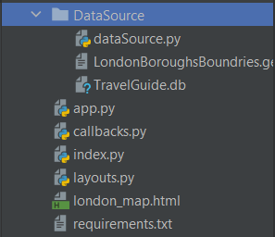

1. Run the “index.py” file.
2. Click on the link that occurs in the output section.

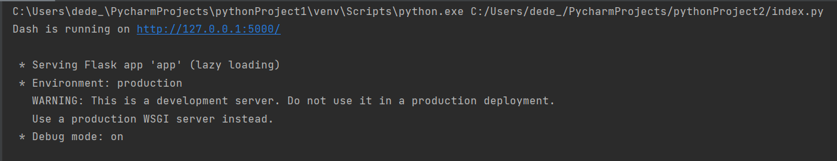

1. Next, when the web page runs, set your criteria by selecting the neighbourhood, property type, number of bedrooms, and set price range (min and max).

# Hint: min price should have a value less than the max price.

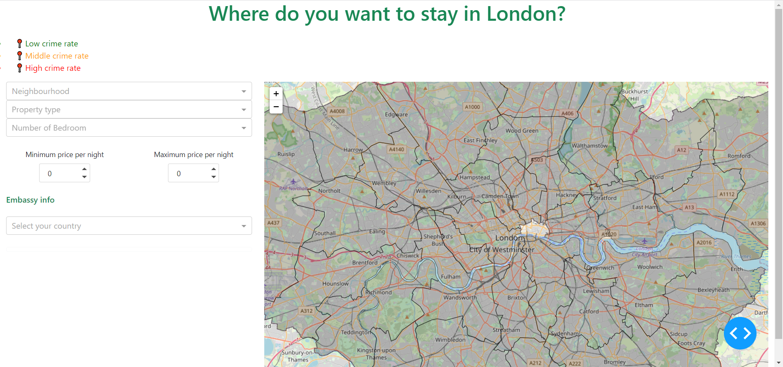

1. Then, when the properties markers appear on the map, click on one of them to show the pop-up with summary information about the property.

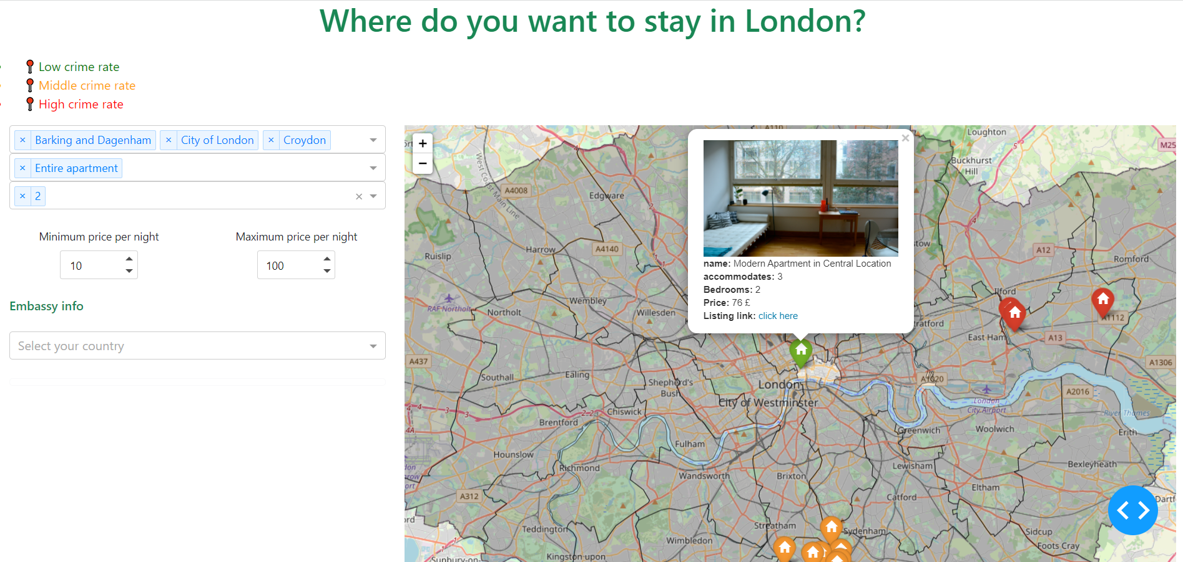

1. To navigate to the property page, you should click on the listing link in the pop-up.
2. After that, a property page will open in a new tap. To navigate to the property page Airbnb website, click on the “Click to see it in Airbnb” button.
3. To check the nearby places and transportation, you should scroll down on the property page and click on one of the buttons.

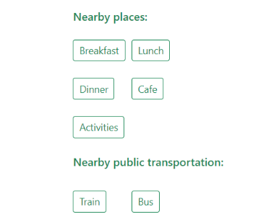

1. To filter the food venues based on your diet type, click on one of these buttons (Breakfast, Lunch, Dinner or café). Then you will be navigated to a page with a drop-down list, from this list select your diet type or any type.

Hint: it may take a long time to show the results.

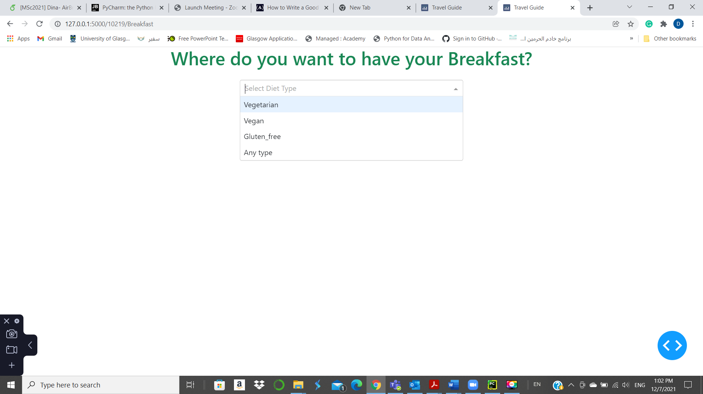

1. To reach the embassy information go to the map page then select the country from the Embassy info drop-down list.



#Hint: Data_Cleaning_py file is not an executable file. It was used to clean and process the data before using them in the project. However, this file shows the effort that pay in the early stages of the project as this stage consumed approximately one-third of the project time.